Marks claimed

An outdoor section built using the Terrain editor (including billboard textures, trees, hills and crevices, appropriate textures, etc.) (25%)

An indoor section built using ProBuilder (25%)

Appropriate textures on the indoor section (5%)

* Throughout

With normal maps (add 5%)

* Throughout

Direct light sources beyond the default Directional Light (5%)

* Overhead Lights

Use of emissive materials (add 5%)

* The Art Installation Pedestals
* The Overhead Lights
* On the Doors
* The Portals

Use of reflection-probes and reflective surfaces (add 5%)

* Lambda Statue

Use of multiple cameras (e.g. overlaid cameras or rendering to a texture) (10%)

* Portal Art Installation

Particle effects (10%)

* Fountains

Objects controlled by physics (5%)

* Red Ball
* Stationary on desk

The Garden

I started with the glass-enclosed garden (terrain). The terrain features grass, trees, and a pond. The pond has a water fountain underneath (particle effect).

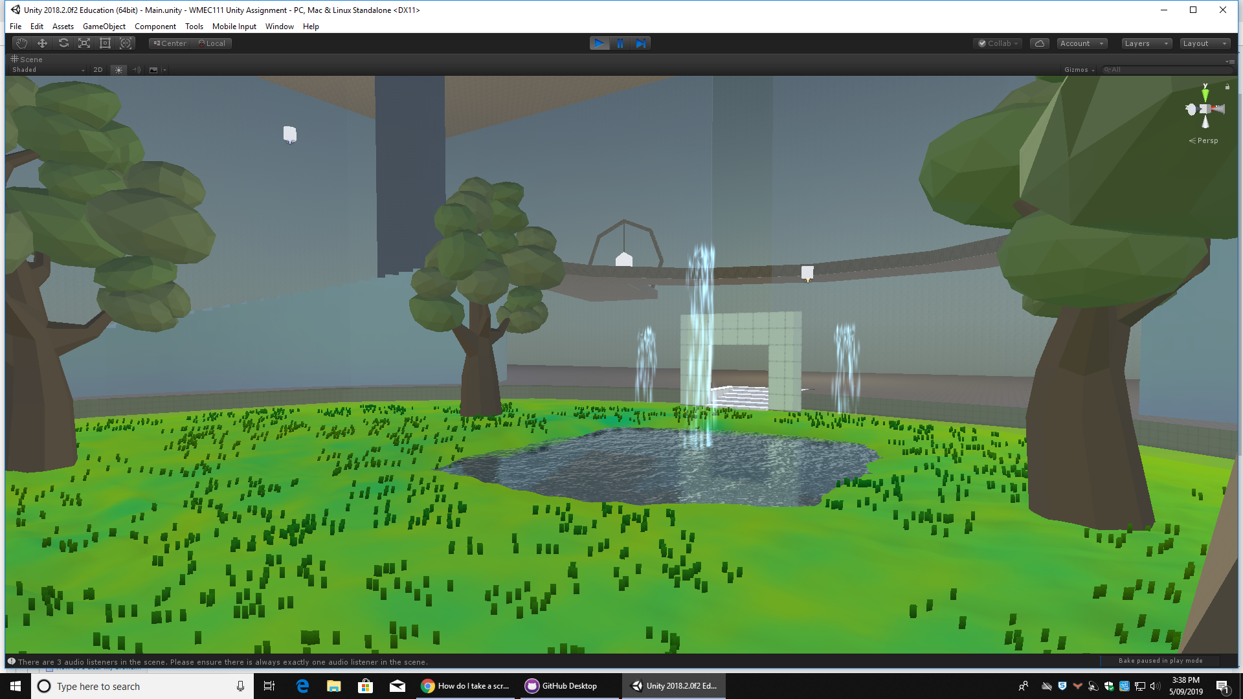

There is also a ball which players can kick around (physics)

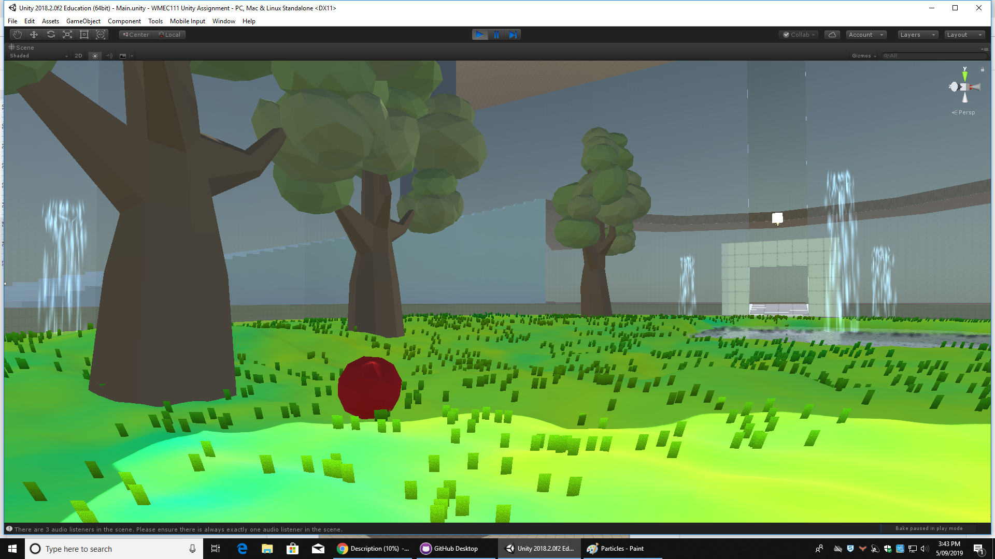

The complex

The Complex was built using ProBuilder. The floor, walls, and ceiling all use appropriate materials, and respective normal maps. Both are also used on the front desk with a writing pad and pen on it (physics).

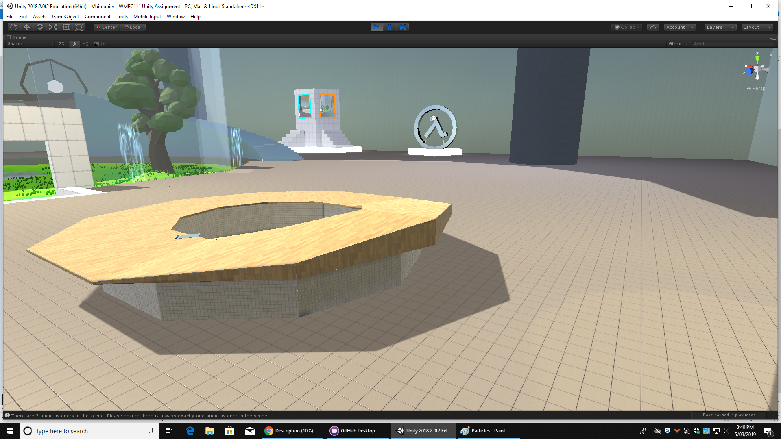

It is lit by overhead lights throughout the room, (emissive material, and alternative light source).

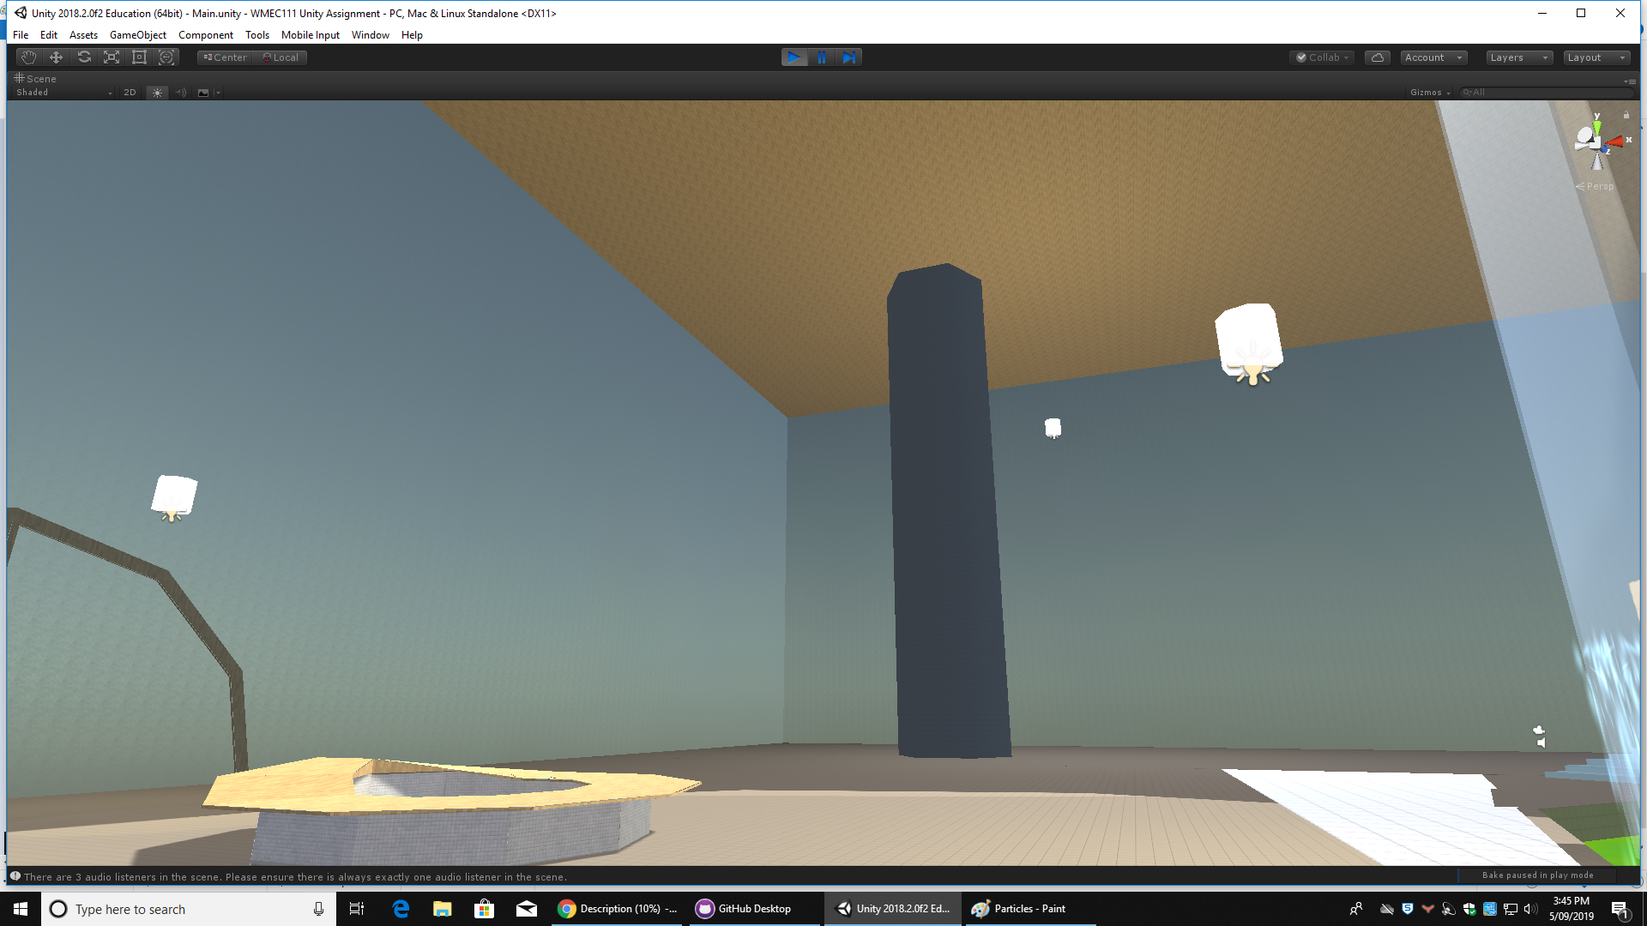

Emissive material is also used on the pedestals of the art installations, achieving the desired lightbox effect. These two installations are a Lambda symbol made of polished metal (reflective surface), and a showcase of portal technology (multiple cameras)

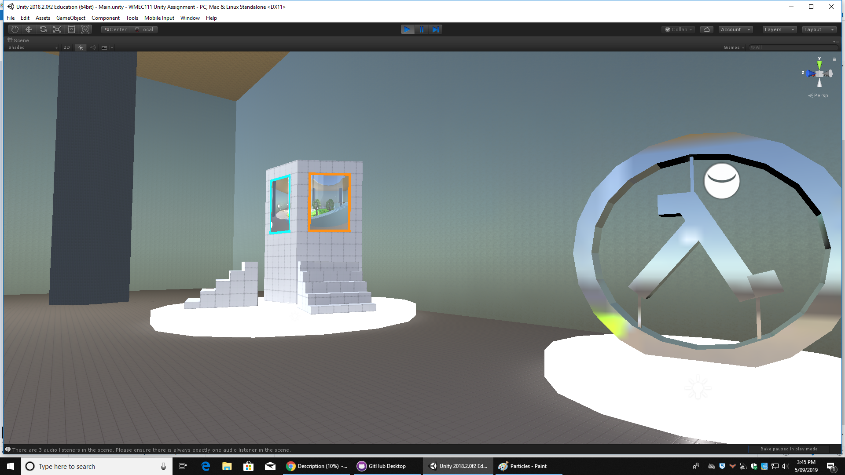

Challenges and changes

Although there weren’t necessarily and changes made in between now and the GDD, compromises were certainly made. In an ideal world the player would be able to pick up physics objects and open doors, but that was too hard for me unfortunately, so players can only knock objects over. The materials used for the indoor section were also not what I had in mind, but aiming for a specific artstyle while relying on free assets is not realistic, so compromises were made.

Assets used:

Darth_Artisan’s Free Trees

Sten Ulfsson’s Office Supplies Low Poly

Nobiax and Yughues’ Yughues Free Concrete Materials

Avionx’s World Materials Free